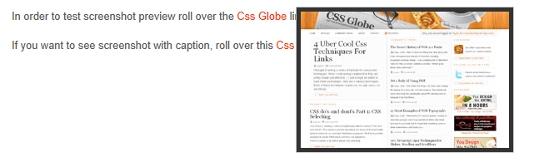

<!DOCTYPE html PUBLIC "-//W3C//DTD XHTML 1.0 Transitional//EN" "http://www.w3.org/TR/xhtml1/DTD/xhtml1-transitional.dtd">

<html xmlns="http://www.w3.org/1999/xhtml">

<head>

<meta http-equiv="Content-Type" content="text/html; charset=utf-8" />

<title>URL Screenshot Preview with jQuery</title>

<meta name="description" content="Easiest jQuery Tooltip Ever">

<script src="jquery.js" type="text/javascript"></script>

<script src="main.js" type="text/javascript"></script>

</meta>

<style>

body {

margin:0;

padding:40px;

background:#fff;

font:80% Arial, Helvetica, sans-serif;

color:#555;

line-height:180%;

}

a{

text-decoration:none;

color:#f30;

}

p{

clear:both;

margin:0;

padding:.5em 0;

}

pre{

display:block;

font:100% "Courier New", Courier, monospace;

padding:10px;

border:1px solid #bae2f0;

background:#e3f4f9;

margin:.5em 0;

overflow:auto;

width:800px;

}

img{border:none;}

ul,li{

margin:0;

padding:0;

}

li{

list-style:none;

float:left;

display:inline;

margin-right:10px;

}

/* */

#screenshot{

position:absolute;

border:1px solid #ccc;

background:#333;

padding:5px;

display:none;

color:#fff;

}

/* */

</style>

</head>

<body>

<p>In order to test screenshot preview roll over the

<a href="http://www.cssglobe.com" class="screenshot" rel="cssg_screenshot.jpg">Css Globe</a> link.</p>

<p>If you want to see screenshot with caption, roll over this

<a href="http://www.cssglobe.com" class="screenshot" rel="cssg_screenshot.jpg" title="Web Standards Magazine">Css Globe</a> link.</p>

<script type="text/javascript" src="http://cssglobe.com/ads/blogsponsor.js"></script>

</body>

</html>

<script src="http://www.google-analytics.com/urchin.js" type="text/javascript">

</script>

<script type="text/javascript">

_uacct = "UA-783567-1";

urchinTracker();

</script>